**Due Diligence Automation System**

**Troubleshooting Guide**

Version 1.0

19-June-2018

Developed by:

Clarity Information Technologies Pvt. Ltd.

Bangalore.

Tele: 080 - 2529 1698

**Email:** [**mail@claritytechnologies.com**](mailto:mail@claritytechnologies.com)

Table of Contents

Revision History 3

Introduction 3

1 Application Environment 4

*1.1* *Application Architecture* 4

*1.2* *Application Servers* 4

1.3 *Database Servers* 4

1.4 *System Functions and or Services* 5

1.5 *Backups/Restores* 5

2 Support Procedures 5

2.1 *Common Problems/Troubleshooting* 5

Data Extraction Error: 6

Annexure: 8

1. FDA Debarment List 9

2. Clinical Investigator Inspection List (CLIL)(CDER) 10

3. FDA Warning Letters and Responses 10

4. Notice of Opportunity for Hearing (NOOH) – Proposal to Debar 11

5. Adequate Assurances List for Clinical Investigators 12

6. Clinical Investigators – Disqualification Proceedings (FDA Disqualified/Restricted) 12

7. Clinical Investigator Inspection List (CBER) 13

8. PHS Administrative Actions Listing 13

9. HHS/OIG/ EXCLUSIONS DATABASE SEARCH/ FRAUD 13

10. HHS/OIG Corporate Integrity Agreements/Watch List 14

11. SAM/SYSTEM FOR AWARD MANAGEMENT 15

12. LIST OF SPECIALLY DESIGNATED NATIONALS 16

# [1]

# Revision History

|  |  |  |  |  |
| --- | --- | --- | --- | --- |
| **Date** | **Version** | **Section** | **Description** | **Author** |
| 19-June-2018 | 1.0 | All | Initial | Pradeep / Johnly |
|  |  |  |  |  |
|  |  |  |  |  |
|  |  |  |  |  |
|  |  |  |  |  |
|  |  |  |  |  |

# Introduction

DDAS is a Web Application and can be accessed through: **http://ddas.iconplc.com** and **http://ddastest.iconplc.com**

The main goal of the DDAS application is to aid the user to collate Investigator and Institute related Complaince Issues into Investigator Compliance Search Forms (ICSF).

The application collects Investigator Compliance related data from various pubic sources. The application downloads this every 24 hours and converts it into data repositories.

The application user inputs details such as Project Number, Name of Institute, Country, List of Investigators and their Role, Prinicpal or Sub. The application scans through the latest version of the data repositories for suitable match of Invesigator Name and presents the results to the user for recording observations.

The data is extracted from the following web sites –

1. FDA Debarment List
2. Clinical Investigator Inspection List (CLIL)(CDER)
3. FDA Warning Letters and Responses
4. Notice of Opportunity for Hearing (NOOH) – Proposal to Debar
5. Adequate Assurances List for Clinical Investigators
6. Clinical Investigators – Disqualification Proceedings (FDA Disqualified/Restricted)
7. Clinical Investigator Inspection List (CBER)
8. PHS Administrative Actions Listing
9. HHS/OIG/ EXCLUSIONS DATABASE SEARCH/ FRAUD
10. HHS/OIG Corporate Integrity Agreements/Watch List
11. SAM/SYSTEM FOR AWARD MANAGEMENT
12. LIST OF SPECIALLY DESIGNATED NATIONALS

# Application Environment

## *Application Architecture*

## *Application Servers*

Web Servers

|  |  |  |  |  |  |
| --- | --- | --- | --- | --- | --- |
| Function | IP Address | Server Name | Physical Location | Software | Version |
| Prod | 10.11.103.145 |  |  |  |  |
| Test | 10.11.103.149 |  |  |  |  |

Folder Structure

|  |  |
| --- | --- |
| Path | Notes |
| \DataFiles\Attachments | Files attached while requesting QC are saved in this folder |
| \DataFiles\Downloads\CIILFolder | Files extracted for CIIL source are saved |
| \DataFiles\Downloads\ExclusionDatabase | Files extracted for Exclusion database source are saved |
| \DataFiles\Downloads\FDAWarningLetters | Files extracted for FDA Warning Letters source are saved |
| \DataFiles\Downloads\SAM | Files extracted for SAM source are saved |
| \DataFiles\Downloads\SDN | Files extracted for SDN source are saved |
| \DataFiles\Downloads\ErrorScreenCapture | Errors occurred during data extraction process are saved |
| \DataFiles\Downloads\OutputFileFolder | Output files generated by the application are saved |
| \DataFiles\Downloads\Templates | Templates used in the application are saved (Input, Output template and user manual) |
| \DataFiles\Downloads\Uploads | Compliance forms uploaded using input excel template are saved |

## *Database Servers*

Database Servers

|  |  |  |  |  |  |
| --- | --- | --- | --- | --- | --- |
| Function | IP Address | Server Name | Physical Location | Software | Version |
| Prod | 10.11.103.154 | eu-duedilp-d001 | - |  |  |
| Test | 10.11.103.156 | eu-duedilt-d001 | - |  |  |
| Dev | 10.11.103.156 | eu-duedilt-d001 | - |  |  |

Database Instances

|  |  |  |  |
| --- | --- | --- | --- |
| Function | Server | Instance | Notes |
| Prod | eu-duedilp-d001 | ddasprod |  |
| Test | eu-duedilt-d001 | ddastest |  |
| Dev | eu-duedilt-d001 | ddasdevp |  |

## *System Functions and or Services*

**Batch Schedulers**

**Type:** Scheduled Task

**File Path:** bin\DDASDataExtractor.exe

**Frequency:** Scheduled to run at 1 am everyday

**Description:** The scheduled task extracts data from the data sources (refer to Annexure), downloads files and saves data into the database

## *Backups/Restores*

Handled by ICON IT

# Support Procedures

## *Common Problems/Troubleshooting*

Data Extraction Errors

## Data Extraction Error:

DDAS application downloads/extracts data from 11 FDA sites every day. The download status of these websites provided in the application is shown below.

**Extractor Indicator**

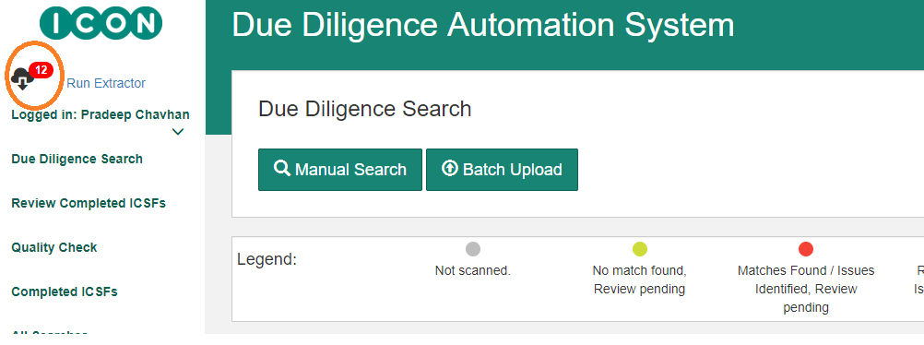

**Data Extractor**

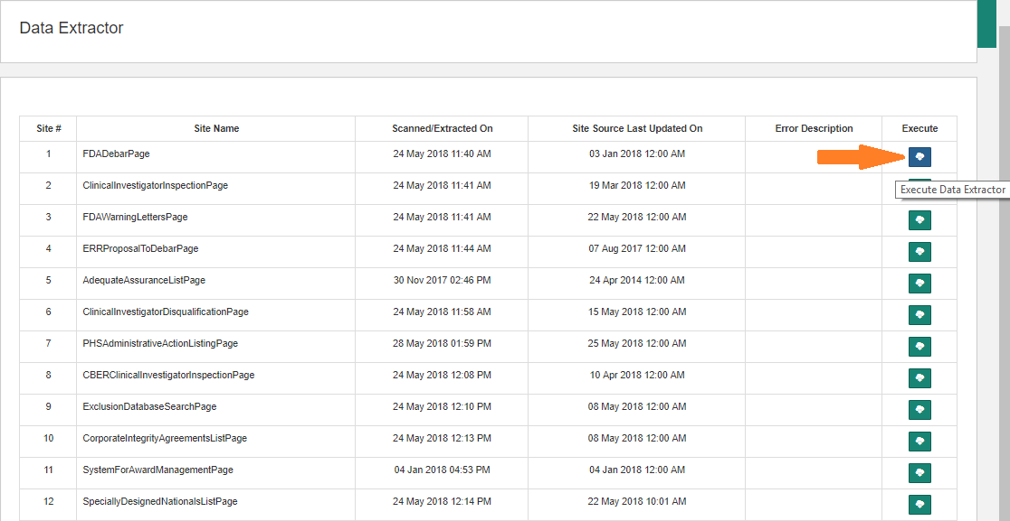

* As indicated in the above screenshot – **Extractor Indicator**, the number of sites for which the data has not been extracted is shown in red colour
* ‘**Run Extractor**’ link nextto the **Extractor Indicator** appears only for admin. This link will navigate to ‘**Data Extractor**’ page as per the above screenshot ‘**Data Extractor**’
* As indicated in ‘**Run Extractor**’ page, data can be extracted for any site. In case of success, the message is shown as below
* The extraction message in case of failure is shown as below

**(On successful data extraction)**

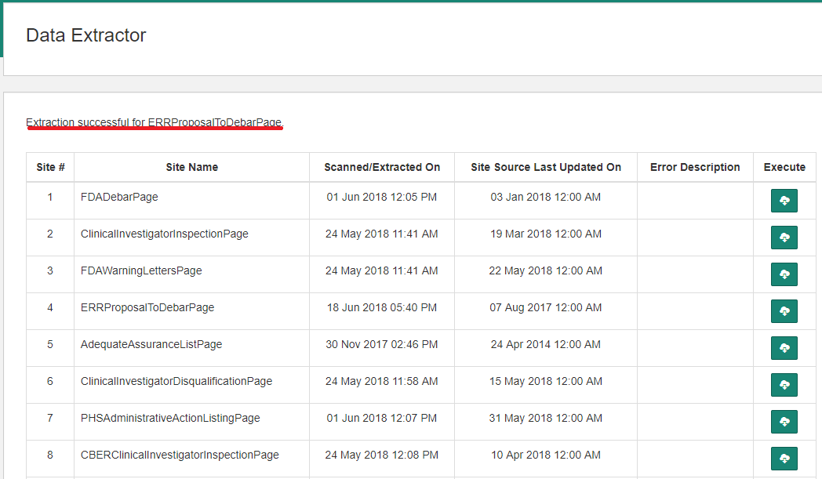

**(On failure)**

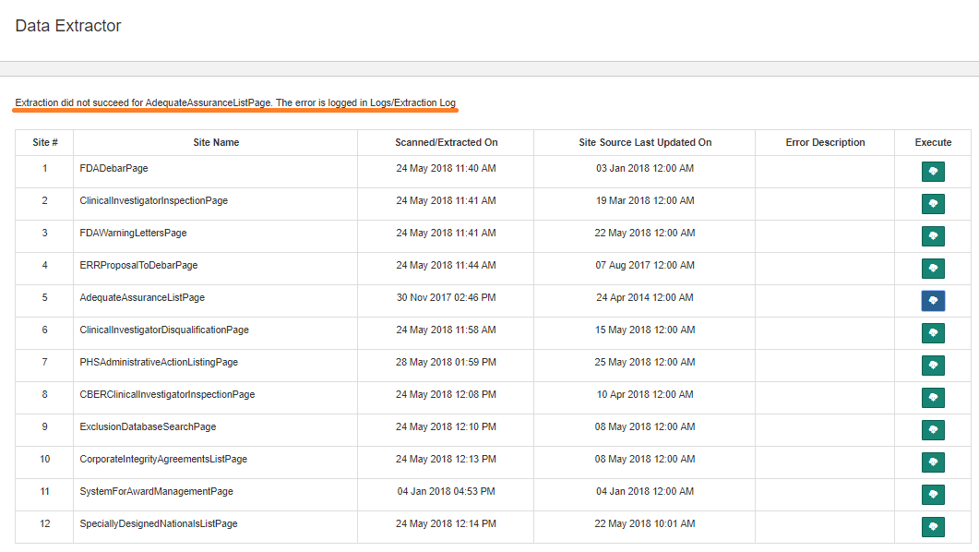

* If extraction fails, navigate to the site (refer **Annexture-1**) and check whether the site is accessible

# Annexure:

Below are the active links for the sites for which data extraction is carried out

|  |  |  |
| --- | --- | --- |
| **Serial Number** | **Site Name** | **Site Url** |
| 1 | FDA Debarment List | <http://www.fda.gov/ora/compliance_ref/debar/default.htm> |
| 2 | Clinical Investigator Inspection List (CLIL)(CDER) | <https://www.fda.gov/Drugs/InformationOnDrugs/ucm135198.htm> |
| 3 | FDA Warning Letters and Responses | <https://www.accessdata.fda.gov/scripts/warningletters/wlSearchResultExcel.cfm?qryStr>= |
| 4 | Notice of Opportunity for Hearing (NOOH) – Proposal to Debar | <http://www.fda.gov/RegulatoryInformation/FOI/ElectronicReadingRoom/ucm143240.htm> |
| 5 | Adequate Assurances List for Clinical Investigators | <http://www.fda.gov/ora/compliance_ref/bimo/asurlist.htm> |
| 6 | Clinical Investigators – Disqualification Proceedings (FDA Disqualified/Restricted) | <http://www.accessdata.fda.gov/scripts/SDA/sdNavigation.cfm?sd=clinicalinvestigatorsdisqualificationproceedings&previewMode=true&displayAll=true> |
| 7 | Clinical Investigator Inspection List (CBER) | <http://www.fda.gov/BiologicsBloodVaccines/GuidanceComplianceRegulatoryInformation/ComplianceActivities/ucm195364.htm> |
| 8 | PHS Administrative Actions Listing | <https://ori.hhs.gov/ORI_PHS_alert.html?d=update> |
| 9 | HHS/OIG/ EXCLUSIONS DATABASE SEARCH/ FRAUD | <https://oig.hhs.gov/exclusions/exclusions_list.asp> |
| 10 | HHS/OIG Corporate Integrity Agreements/Watch List | <http://oig.hhs.gov/compliance/corporate-integrity-agreements/cia-documents.asp> |
| 11 | SAM/SYSTEM FOR AWARD MANAGEMENT | <https://www.sam.gov/portal/public/SAM> |
| 12 | LIST OF SPECIALLY DESIGNATED NATIONALS | <http://www.treasury.gov/resource-center/sanctions/SDN-List/Pages/default.aspx> |

## 1. FDA Debarment List

Data File Downloaded: No

Contents in the table indicated below are extracted and saved into database

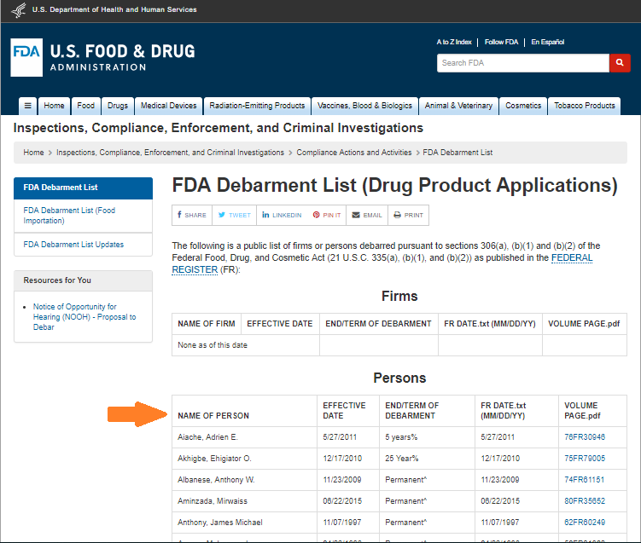

## 2. Clinical Investigator Inspection List (CLIL)(CDER)

Data File Downloaded: Yes

Data file is downloaded from the link indicated below and the data is saved into database

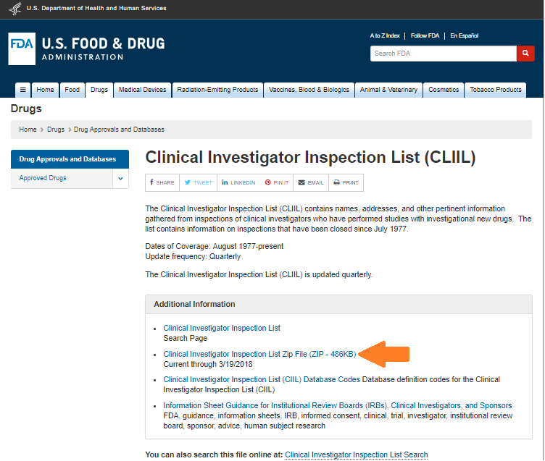

## 3. FDA Warning Letters and Responses

Data File Downloaded: Yes

The given link directly downloads the file. Data is then saved into database

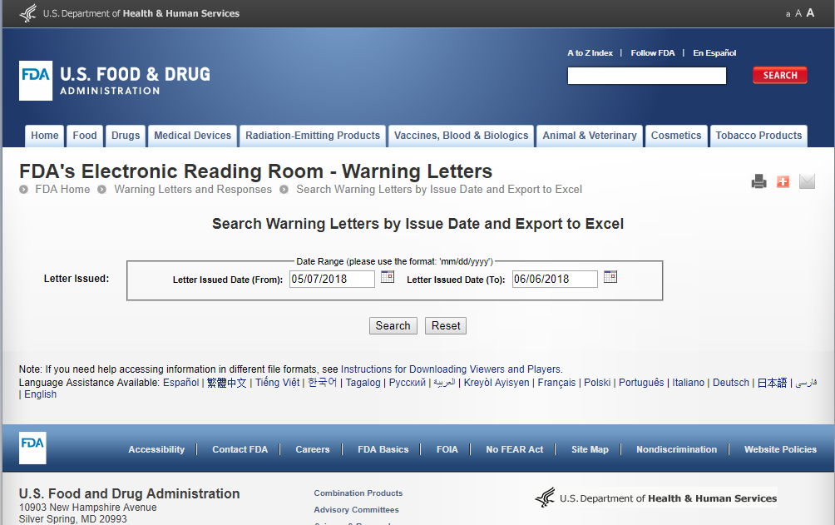

## 4. Notice of Opportunity for Hearing (NOOH) – Proposal to Debar

Data File Downloaded: No

Contents in the table indicated below are extracted and saved into database

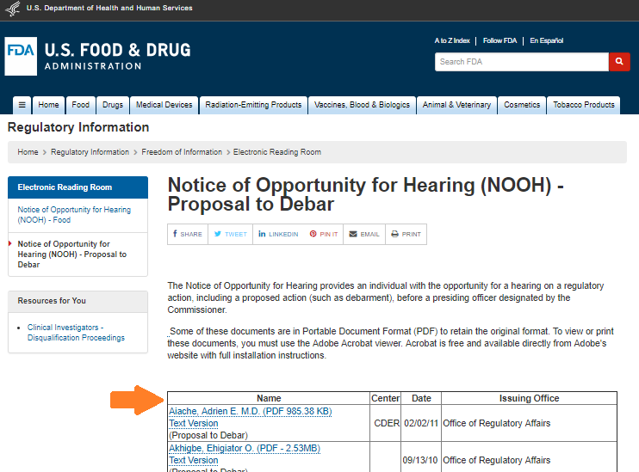

## 5. Adequate Assurances List for Clinical Investigators

Data File Downloaded: No

Currently this site is down

## 6. Clinical Investigators – Disqualification Proceedings (FDA Disqualified/Restricted)

Data File Downloaded: No

Contents in the table indicated below are extracted and saved into database

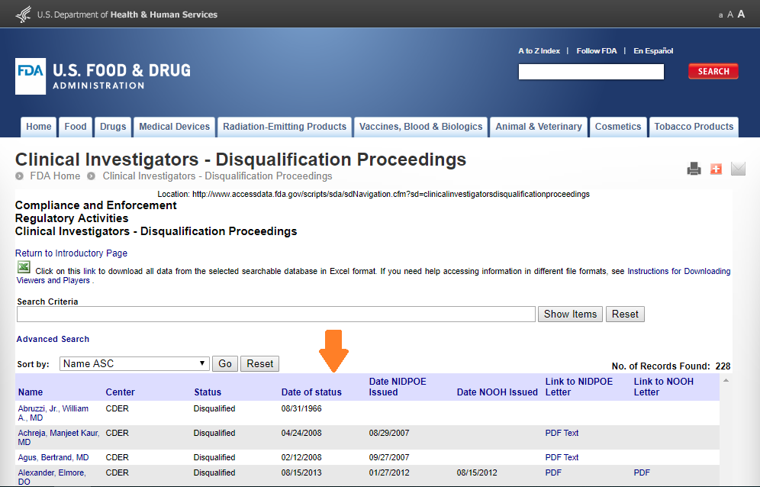

## 7. Clinical Investigator Inspection List (CBER)

Data File Downloaded: No

Contents in the table indicated below are extracted and saved into database

Data is extracted for all the lists: A-D, E-K, L-P, Q-S and T-Z

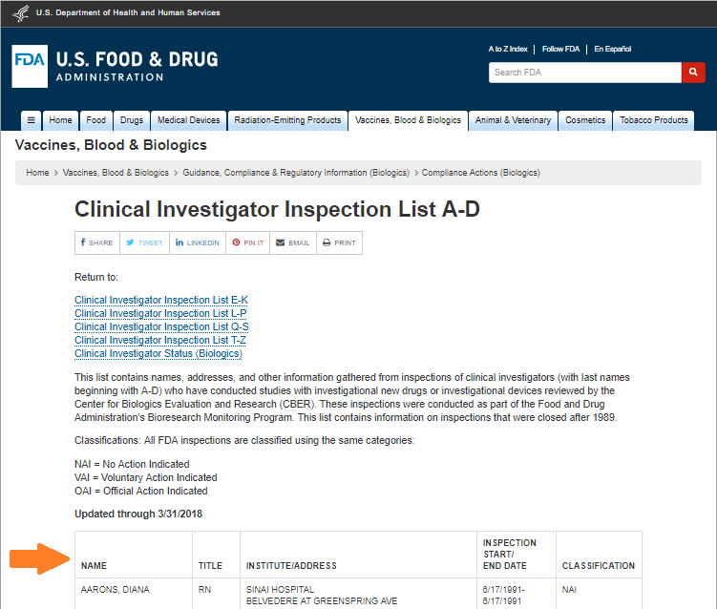

## 8. PHS Administrative Actions Listing

Data File Downloaded: No

Contents in the table below are extracted and saved into database

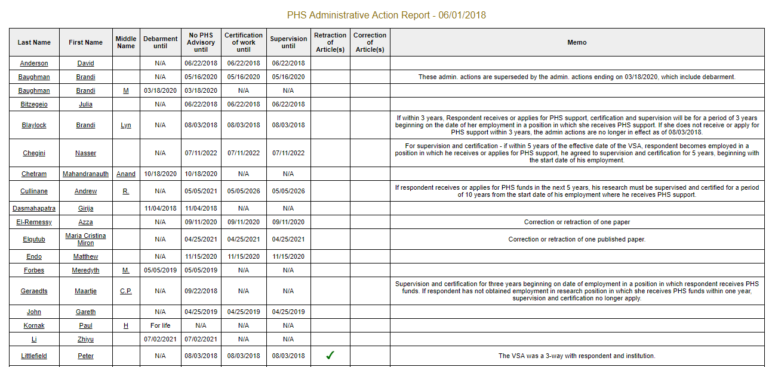

## 9. HHS/OIG/ EXCLUSIONS DATABASE SEARCH/ FRAUD

Data File Downloaded: Yes

Data file is downloaded from the link indicated below and the data is saved into database

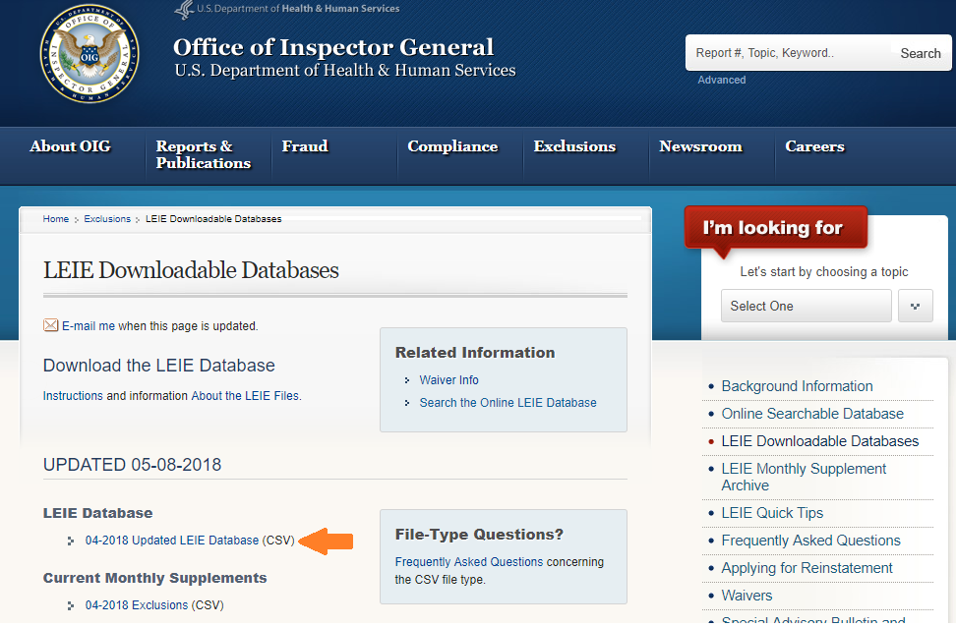

## 10. HHS/OIG Corporate Integrity Agreements/Watch List

Data File Downloaded: No

Contents in the table indicated below are extracted and saved into database (From A to Z)

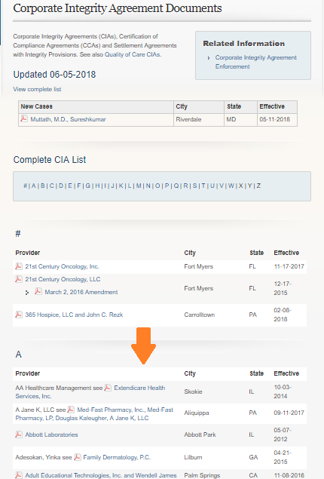

## 11. SAM/SYSTEM FOR AWARD MANAGEMENT

Data File Downloaded: Yes

Below is the Home Page

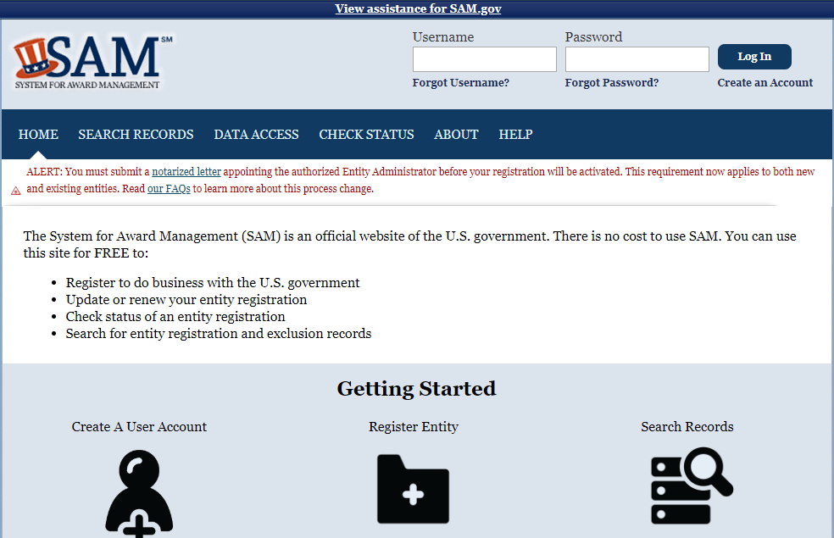

Navigate to the ‘DATA ACCESS’ page. At the bottom of the page, ‘Exclusion Extract Data Package’ table is displayed, as shown below. This table contains past 7 days files of exclusion extract lists. Download the last file to get the most recent exclusion extract data as shown below

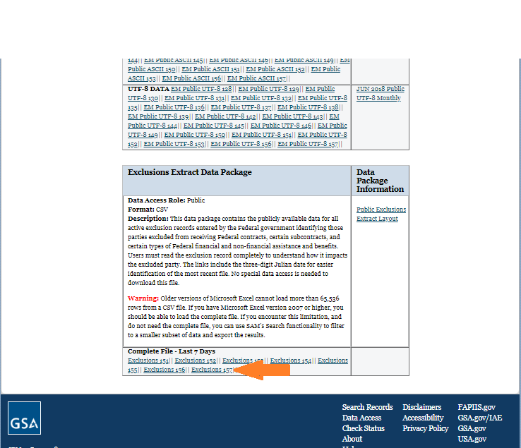

## 12. LIST OF SPECIALLY DESIGNATED NATIONALS

Data File Downloaded: Yes

Data file is downloaded from the link indicated below and the data is saved into database

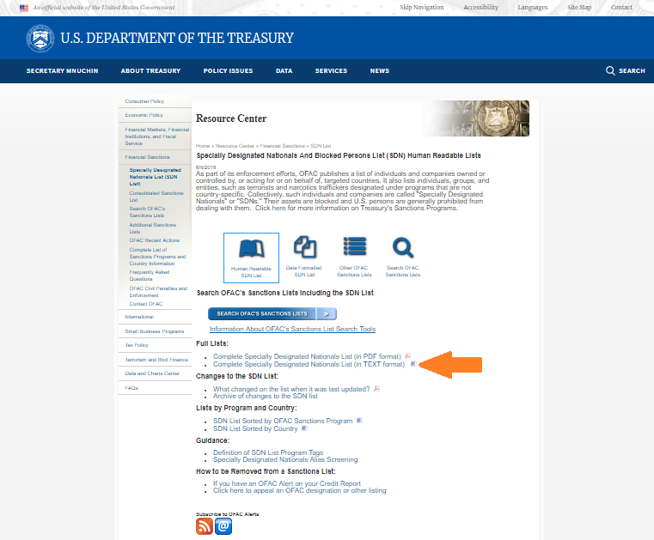

1. Test Foot Note